**DAILY ONLINE ACTIVITIES SUMMARY**

|  |  |  |  |  |  |  |  |
| --- | --- | --- | --- | --- | --- | --- | --- |
| **Date:** | **29/05/2020** | | | | **Name:** | **Rohan Vashista BM** | |
| **Sem & Sec** | **6th Sem & B** | | | | **USN:** | **4al17CS078** | |
| **Online Test Summary** | | | | | | | |
| **Subject** | | **OR Test2** | | | | | |
| **Max. Marks** | | **30** | | **Score** | | **Technical issue (NA)** | |
| **Certification Course Summary** | | | | | | | |
| **Course** | **Full Stack Web development** | | | | | | |
| **Certificate Provider** | | | **Udemy** | **Duration** | | | **20hrs** |
| **Coding Challenges** | | | | | | | |
|  | | | | | | | |
| **Status: completed** | | | | | | | |
| **Uploaded the report in Github** | | | | **yes** | | | |
| **If yes Repository name** | | | | <https://github.com/Rohanvasista/Coding-activities> | | | |
| **Uploaded the report in slack** | | | | **yes** | | | |

**Online test details**

* couldn’t attend due to technical problem

**Online Certification Details**

Completed modules

* Intoduction
* HTML
* CSS
* ReactJS
* Bootstrap
* Laravel

**Webinar :**

* Webinar by wipro by Mohan kumar.

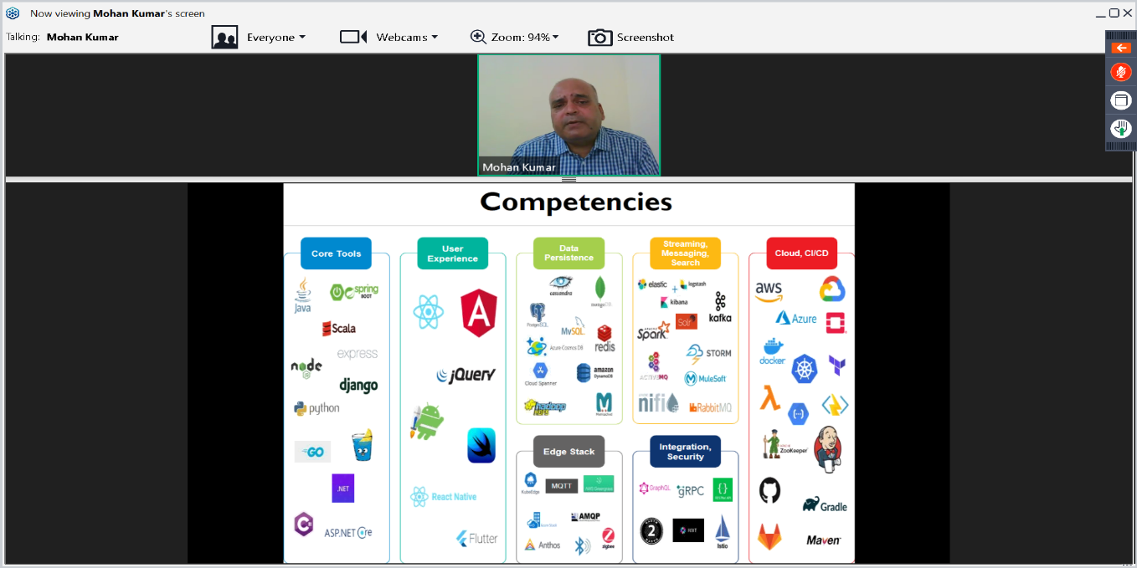

**Coding Challenge Details**

1. This program implemented in order to get the direct values using Chinese remainder theorem in C.

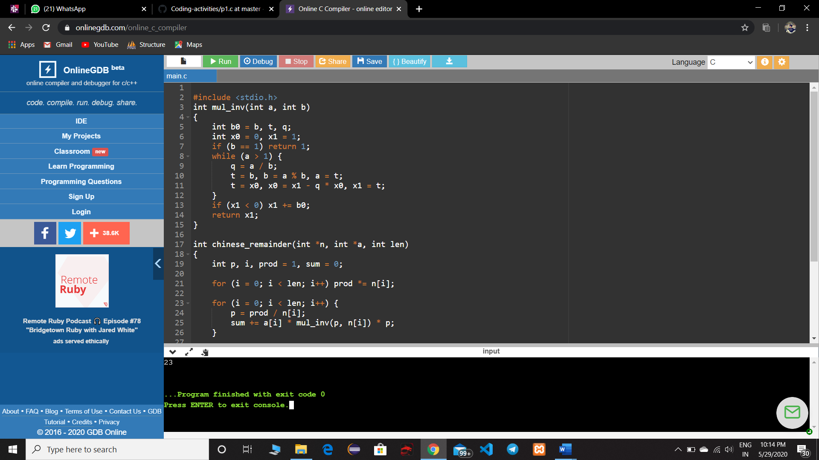

**2.**This java program shows the string interleaved or not.

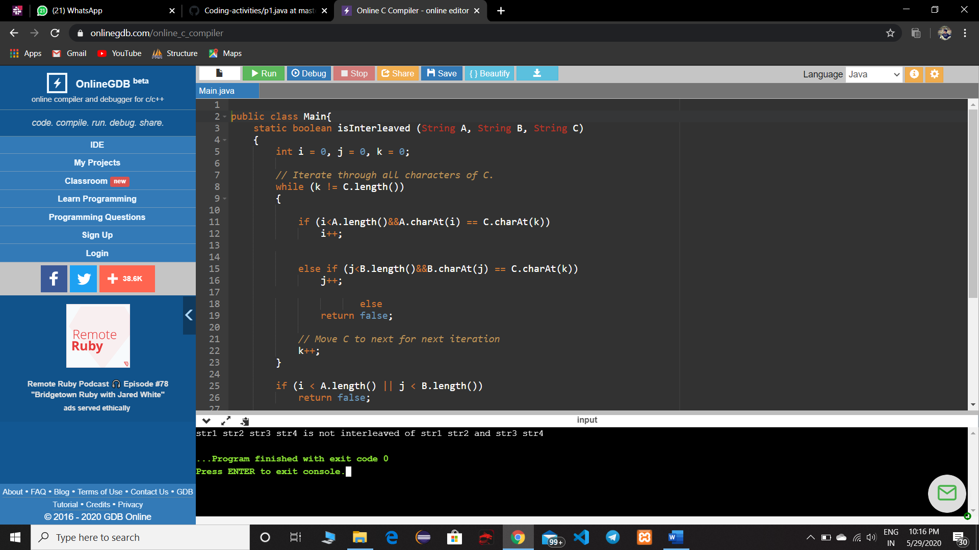

3. This python program takes the input from user and calculate total number of lowercases and uppercases in the string.

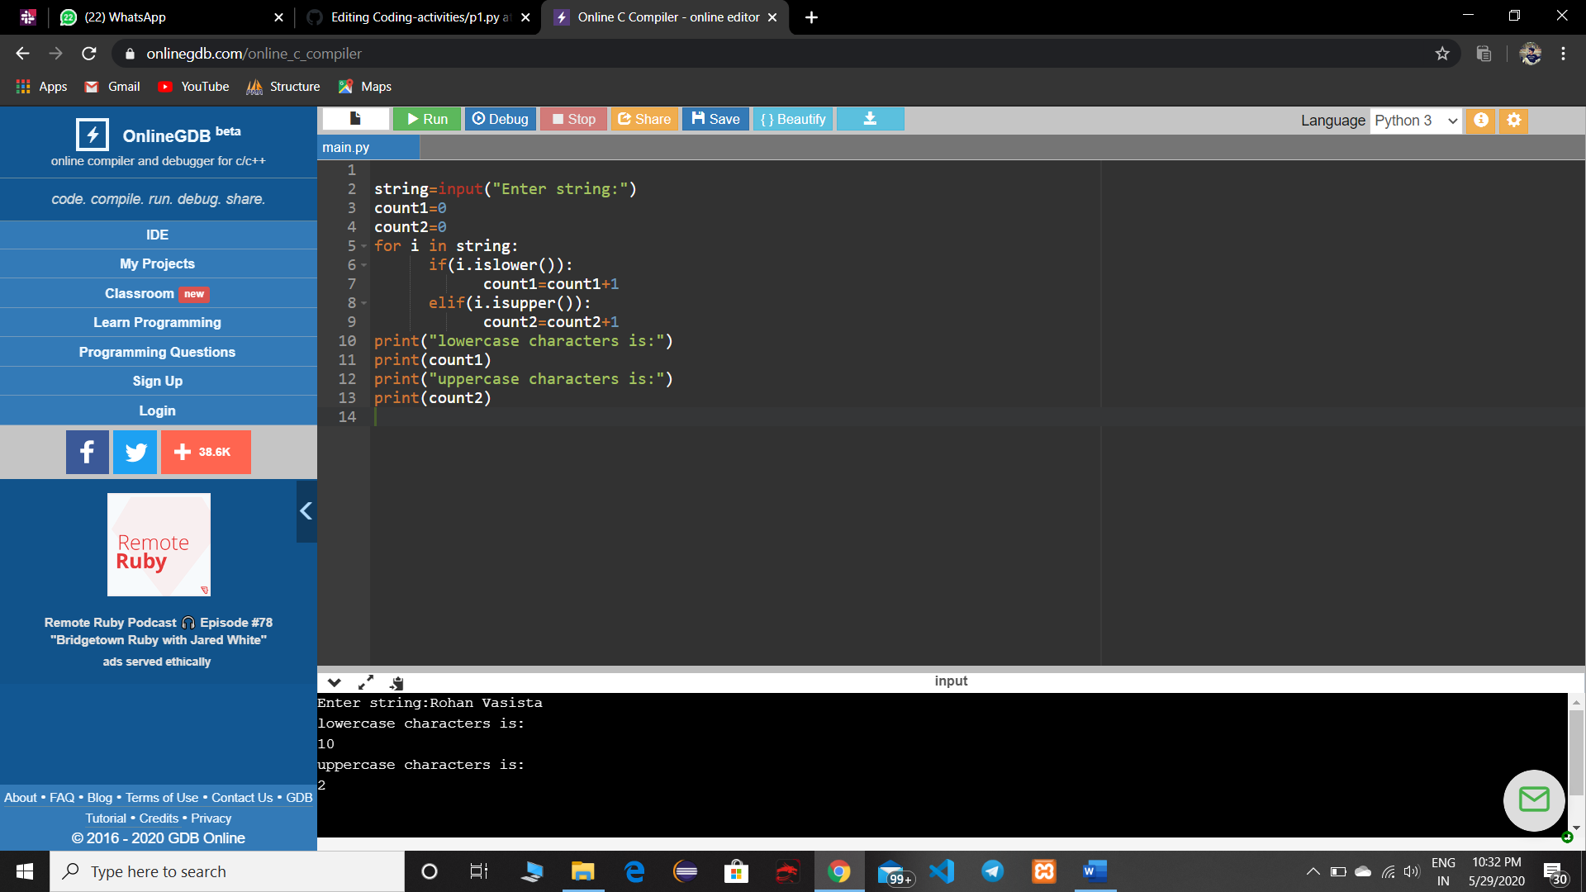

4. Write a Java Program to find longest substring without repeating characters in a string.

